FACULTY DETAILS PROFORMA FOR COLLEGE WEBSITE
Title | Mrs. | First Name | SHABANA | Last Name | WIQUAR | Photograph
Designation |  | ASSOCIATE PROFESSOR |  |  |  | 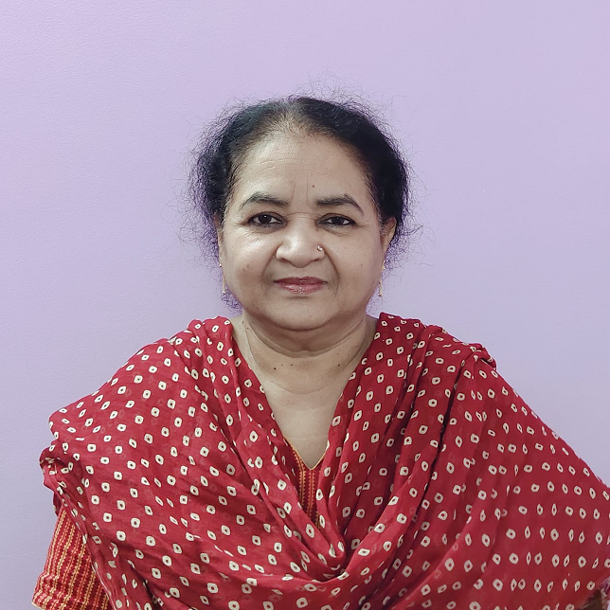
Address |  | 403/ B-12, Shaheen Bagh, Thokar No. 7,  Jamia Nagar, Okhla, New Delhi  Delhi-110025
Mobile No |  | 9891448989
Email |  | shabanawiquar@yahoo.com
Web-Page |  | ---
Educational Qualifications
Degree |  | Institution |  |  |  | Year
B.Com |  | Daulat Ram College, Delhi University |  |  |  | 1978
M.Com |  | Delhi School of Economics, Delhi University |  |  |  | 1980
A short note about yourself (Not more than 500 words)
Great pleasure to have become senior most teacher in the College amongst all the departments having had the good fortune of working with five regular principals over a period of about forty years. The teaching career ranges over several course revisions like FYUP & CBCS entailing teaching Commerce even to students of other streams. It was a challenge made possible due to Multi-lingual communication skills in English, Hindi & Urdu which made explaining the fundamental concepts to students from different backgrounds in their comfortable mediums of learning.
Interaction with the students from different areas was always a challenge. My devotion and sincerity helped my students to achieve exemplary success in their careers. Flexibility given to students to discuss their problems even after the class and giving extra attention by holding additional classes whenever needed, paying extra attention towards students by providing books and notes etc. made me proud of my efforts. Creativity nurturing was designed by encouraging students to contribute articles for Biz-Today – a new Commerce Department magazine founded specially to foster writing on financial topics
Nonverbal communication by studying the students conduct and behavior and monitoring their progress by silently marking their activities in the College and encouraging them in their rightful endeavors and guiding them over their full tenure in the College for building up a solid foundation for their successful placement was always a goal. Such a long journey of teaching hundreds of students entailed immense patience and perseverance at every step where freshers from all walks of life enter the college environment, still used to their school routine. The transition to a more serious, sober and self-disciplined academic approach makes the teacher’s role very crucial.
The Pandemic resulted in suspension of physical classes and beginning of a new technology of online teaching where everything switched to digital learning and newer educational tools like online presentations. Students appraisals were redrafted keeping in mind the constraints of lockdown. Performance Evaluation s was reset without compromising the quality of assessment.

Career Profile
Attended refresher courses at CPDHE Delhi University and Jamia Millia Islamia
Attended Orientation programme atAcademic Staff College Jamia Millia Islamia
Thrtee days Workshop at LLL Delhi University

Administrative Assignments
- Member of Work Load Committee
- Member of Admission Committee
- Member of Time Table Committee
- Convener & Member of Library Committee
- Editor of Commerce Magazine- Biz-Today
- Incharge Girls Common Room
- Member Students Grievance Committee
- Member Internal Complaints Committee
- Resource Speaker on Union Budget 2015-16
- UGC sponsored National Conference organized by Commerce Deptt in 2015

Areas of Interest / Specialization
Income Tax
Management
Subjects Taught
- Income Tax Law & Practice
- Business Organisation & Management
- Custom Laws
- Company and Compensation Law
- Human Resource Management

Research Guidance
---

Publications Profile
- Published various articles in Biz-Today- Commerce Department Magazine

Publications in the Last one year
---
Conference Organization/ Presentations (in the last three years)
---
Research Projects (Major Grants/Research Collaboration)
---
Awards and Distinctions
---
Association With Professional Bodies
- Member of Indian Commerce Association (ICA)

Other Activities
- Coordinated various cultural events like poster making, Rangoli making, mehndi, singing, dancing competition etc.
- Organized debates and essay writing copetitions and quizzes
- Joined in various College trips

You are also requested to also give your complete resume as a PDF file to be attached as a link on your faculty page.

